**RESUME**

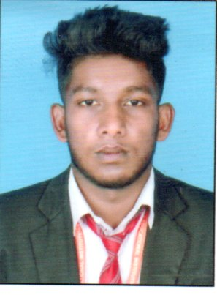**Prashanth T S**

**S/O Shekhar**

**Thanniruhalla Village**

**Masagodu Post**

**Somwarpet Taluk**

**Kodagu Dist -** 571236

**Karnataka State**

**India.**

**Mobil NO : 6362535564**

**Email Id : prashanthprashanth03328@gmail.com**

**PROFESSIONAL OBJECTIVE:**

**To Utilize My Skills And Knowledge In A Right Way To Achive A Good Position In The Industry And Thereby Contribute To The Growth Of The Organization.**

**EDUCATIONAL QUALIFICATIONS:**

|  |  |  |  |  |
| --- | --- | --- | --- | --- |
| **Course** | **University/ Board** | **Institution** | **Year Of Passing** | **Percentage** |
| **SSLC** | **KSEEB** | **GOVT HIGH SCHOOL NERUGALALE,SOMWARPET** | **2015** | **64.48%** |
| **PUC** | **PUE** | **JUNIOR COLLEGE SOMWARPET** | **2017** | **59.33%** |
| **DEGREE ( B.COM)** | **MANGALORE UNIVERSITY** | **ST JOSEPH’S DEGREE COLLEGE SOMWARPET** | **2020** | **57.00%** |

**SKILL**

* **Self Confidence And Great Patience**
* **Work With Positive Attitude To Contribute The Healthy Functioning Of The Organization**
* **Adaptability To The Change Environment**
* **Ability To Cope Up With Different Situations.**

**EXPERIENCE**

**Fresher.**

**TECHNICAL SKILLS:**

**DECA [**Diploma in Computer Application ]

**LANGUAGE KNOWN:**

**Kannada, English,Tamil, Malayalam.**

**HOBBIES**

**Travelling , Sports,Reading Books**.

**PERSONAL PROFILE:**

**Name : Prashanth T S**

**Father Name : Shekhar**

**Mother Name : Govindamma**

**Date Of Birth : 10/02/2000**

**Gender : Male**

**Marital Status : Unmarried**

**Nationality : Indian**

**DECLEARATION:**

**I Hereby Declare That Above Information Is True And Correct To The Best Of My Knowledge.**

**Place *:*  Somwarpet**

**Date : Your Sincerely**

**(Prashanth T S)**